**Database Lab**

**Report**

**Lab 04**

Sharjeel Akram

BSCS-2019-60

Sir Shafi Ullah

In the Lab 4 first we have connected mysql with python. I did this using a command that was already written in the lab manual

**pip3 install mysql-connector-python**

I checked it and it was working successfully.

According to the lab manual first I created a GUI of login page on which there are four things

* Username
* Password
* Login Button
* Register Button

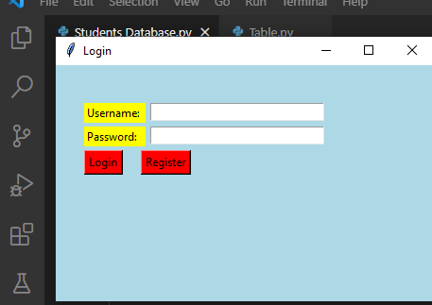

Our first step is completed now.

According to the Lab manual, I created a database and created table named as Students in the database.

Now I enter the first student’s name and password.

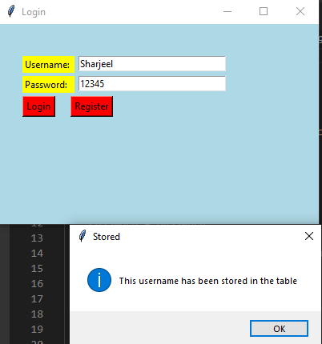

As we can see in the picture that first student’s credential has been stored in the table.

We can add many students in the table but their username should be different every time. When I enter the same username with different password it displays a message inbox.

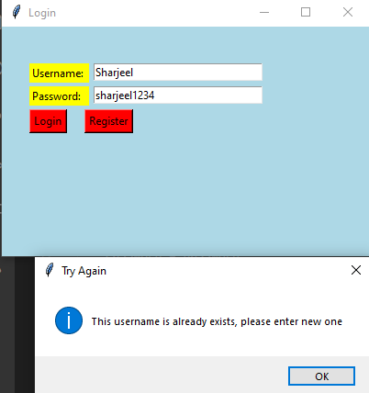

In the above picture as I entered the same username with different password it displays a message that this username already exists.

Now to login with the saved credential I have to click on login button.

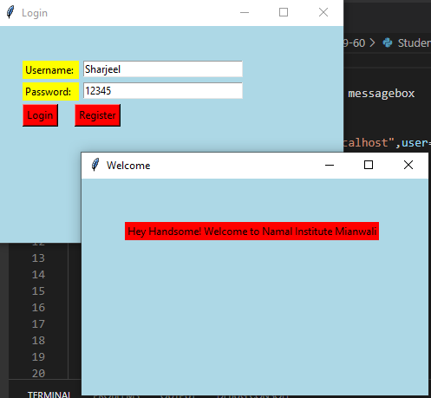

When I clicked on login button I was moved towards a different window which means that my code is working according to the lab manual.

But when I entered invalid credential,

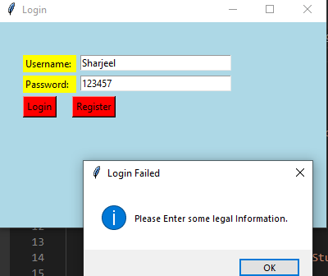

It displays a message that please enter some valid information to login to your page.

It means that my code works according to the given Lab manual.

But if we want to check the table that which credential has been stored we can see it used mysql command client.

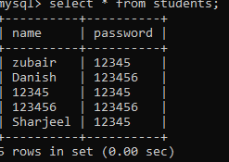

That is the table of students which is stored in Database named as **mydatabase**.